 

## DEPARTMENT OF ELECTRONICS AND COMMUNICATION ENGINEERING

HOSPITAL MANAGEMENT SYSTEM

Submitted by

## KIRUTHIKA V R (927621BEC091)

## MADHUMITHA SRI R (927621BEC108)

## MADHUSRI J (927621BEC109)

**Elite Training Project 2 Report**

**C Programming**

Submission Date: **29/04/2023**

**Signature of Staff Incharge Signature of HOD**

**Signature of Elite Training Coordinator**

**Dr.D.Pradeep, ASP/CSE**

**SUMMARY**

A Hospital Management System (HMS) is software designed to handle electronic medical records, laboratory tests and their results, radiology images, pharmacy records etc. It helps in managing patient data efficiently so that hospitals can provide better care and services. With faster, secure, and easy data retrieval, a hospital/healthcare facility would be able to provide better and efficient care to the patients. With every department interconnected and integrated into the HMS, the quality of patient care can be enhanced, leading to greater customer satisfaction and lowered turnovers. Today there is severe competition even in the realm of healthcare, and patients and their kin prefer to visit a facility that is efficient, cost-effective, and secure.

“Hospital Management System Project” is an application using the C programming language. We used GDB compiler to code this program. In this we can do Patient Record tasks like adding the Patient info and view the added Patient. In this user can add a new patient record choosing the number 1. Users can add name, age, gender, disease, and room number are available. The information is stored in a file. In this user can view the record list choosing the number 2. All the information corresponding to the respective patient is displayed. These include the ones provided while adding a new patient record. In this user can exit by choosing the number 3. If any other number is entered by user it will show invalid choice. Please try again.

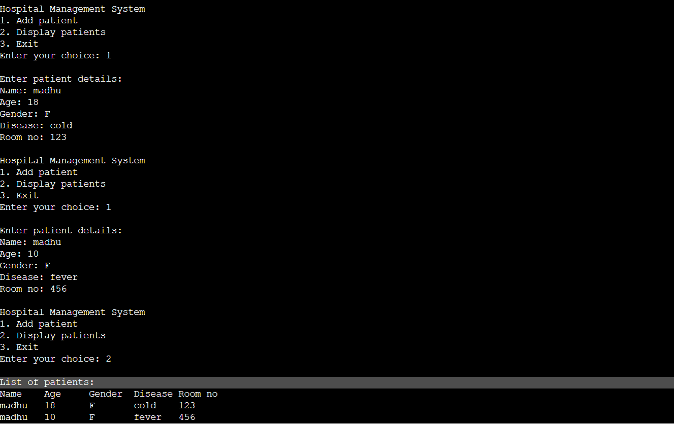 **SCREENSHOT**

**SOURCE CODE**

#include <stdio.h>

#include <stdlib.h>

#include <string.h>

// defining structure for patient details

struct patient {

    char name[50];

    int age;

    char gender[10];

    char disease[100];

    int room_no;

};

// function to add patient details

void add_patient(struct patient *patients, int n) {

    printf("\nEnter patient details:\n");

    printf("Name: ");

    scanf("%s", patients[n].name);

    printf("Age: ");

    scanf("%d", &patients[n].age);

    printf("Gender: ");

    scanf(" %s", &patients[n].gender);

    printf("Disease: ");

    scanf("%s", patients[n].disease);

    printf("Room no: ");

    scanf("%d", &patients[n].room_no);

}

// function to display patient details

void display patients(struct patient *patients, int n) {

    printf("\nList of patients:\n");

    printf("Name\tAge\tGender\tDisease\tRoom no\n");

    for(int i=0; i<n; i++) {

        printf("%s\t%d\t%c\t%s\t%d\n", patients[i].name, patients[i].age, patients[i].gender, patients[i].disease, patients[i].room_no);

    }

}

int main() {

    int choice, n=0;

    struct patient patients[100];

    while(1) {

        printf("\nHospital Management System\n");

        printf("1. Add patient\n");

        printf("2. Display patients\n");

        printf("3. Exit\n");

        printf("Enter your choice: ");

        scanf("%d", &choice);

        switch(choice) {

            case 1:

                add_patient(patients, n);

                n++;

                break;

            case 2:

                display_patients(patients, n);

                break;

            case 3:

                exit(0);

            default:

                printf("\nInvalid choice. Please try again.\n");

        }

    }

    return 0.

}

**CONCLUSION:**

The "Hospital Management System Project" is password-protected, which is good since it ensures that only authorized users may access this program.